**St Edmund’s Church**

Southwold

**Annual Christingle Service**



Christmas Eve at 4:00pm

In aid of



**Welcome**

A very warm welcome to St Edmund’s Church for this special Christingle Service.

Please do join in with singing, actions, and even playing a part in this most wonderful of stories.

As this service involves lit candles, please listen carefully to the safety instructions so that everyone is kept safe.

At the end of the service, we will take a collection to support the incredible work of the Children’s Society. Please give as generously as you can and help some of the most vulnerable children in the UK. You can give cash into the plate, but the most effective way to give is via your phone. You can scan the QR code below to donate:

We hope you really enjoy the service, are blessed by hearing the Christmas story with the unique ‘Southwold spin’ and have a very happy Christmas and a peaceful New Year.

**Safety Tips for Christingles**

Children should be supervised by a responsible adult at all times.

When Christingles are lit, please follow these simple safety tips:

* Keep your chin up!
* Take care with your hair
* Hot wax hurts!
* Don’t be a space invader
* Don’t jingle your Christingle



**Opening Prayer**

*All* **Loving God,**

**as we hear the familiar story of how you came to**

**Earth and were born as a baby**

**in the manager in Bethlehem so long ago,**

**come to us today, be born in us today,**

**and fill our hearts with your peace,**

**your hope and your love,**

**now and always.**

**Amen.**

**The Greatest Story – Scene 1**

**O Little Town of Bethlehem**

O little town of Bethlehem, how still we see thee lie!  
Above thy deep and dreamless sleep the silent stars go by.  
Yet in thy dark streets shineth the everlasting light;  
the hopes and fears of all the years are met in thee tonight.

For Christ is born of Mary; and, gathered all above,  
while mortals sleep, the angels keep their watch of wond'ring love.  
O morning stars, together proclaim the holy birth,  
and praises sing to God the King, and peace to men on earth.

How silently, how silently, the wondrous gift is giv'n!  
So God imparts to human hearts the blessings of His heav'n.  
No ear may hear His coming, but in this world of sin,  
where meek souls will receive Him still, the dear Christ enters in.

O holy Child of Bethlehem, descend to us, we pray;  
cast out our sin and enter in; be born in us today.  
We hear the Christmas angels, the great glad tidings tell;  
O come to us, abide with us, our Lord Emmanuel!

**The Greatest Story – Scene 2**

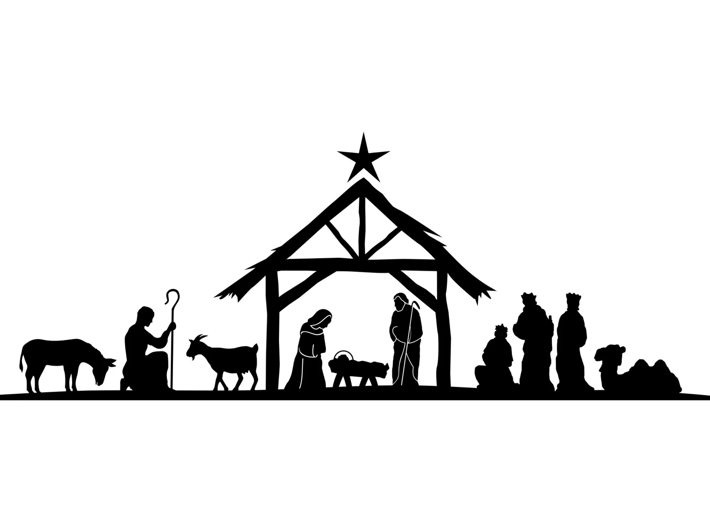

**The Calypso Carol**

See him lying on a bed of straw:  
a draughty stable with an open door;  
Mary cradling the babe she bore  
the prince of glory is his name.

O now carry me to Bethlehem

to see the Lord of love again:just as poor as was the stable then,the prince of glory when he came.

Star of silver, sweep across the skies,  
show where Jesus in the manger lies;  
shepherds, swiftly from your stupor rise  
to see the saviour of the world!

O now carry me to Bethlehem…

Angels, sing again the song you sang,  
sing the glory of God's gracious plan;  
Sing that Bethl'em's little baby can  
be the saviour of us all.

O now carry me to Bethlehem…

Mine are riches, from your poverty,  
from your innocence, eternity;  
mine, forgiveness by your death for me,  
child of sorrow for my joy.

O now carry me to Bethlehem…

**The Greatest Story – Scene 3**

**Hark! The herald angels sing**

Hark! The herald angels sing, "Glory to the new-born king.  
Peace on earth and mercy mild God and sinners reconciled."  
Joyful all ye nations rise, join the triumph of the skies,  
With angelic host proclaim "Christ is born in Bethlehem"  
Hark! The herald angels sing "Glory to the new-born king."

Christ, by highest heaven adored, Christ, the everlasting Lord.  
Late in time behold Him come, offspring of a Virgin's womb:  
Veiled in flesh the Godhead see, hail the incarnate Deity,  
Pleased as man with man to dwell, Jesus, our Emmanuel  
Hark! The herald-angels sing "Glory to the new-born King."

Hail the heaven-born Prince of Peace! Hail the Sun of Righteousness!  
Light and life to all He brings, risen with healing in His wings  
Mild He lays His glory by born that man no more may die  
Born to raise the sons of earth, born to give them second birth  
Hark! The herald angels sing "Glory to the new-born king"

**The Greatest Story – Scene 4**

**O come, all ye faithful**

O come, all ye faithful, joyful and triumphant  
O come ye, o come ye to Bethlehem  
Come and behold Him, born the King of Angels.

*O come, let us adore Him, O come, let us adore Him  
O come, let us adore Him, Christ the Lord.*

God of God, Light of Light  
Lo, He abhors not the Virgin's womb  
Very God begotten, not created.

*O come, let us adore Him…*

Sing, choirs of angels, sing in exultation  
Sing, all ye citizens of heaven above!  
Glory to God, in the highest.

*O come, let us adore Him…*

**Christingles are distributed**

*When all have a lit Christingle, the lights are dimmed and we sing.*

**Away in a manger**

Away in a manger, no crib for a bed,  
The little Lord Jesus lay down His sweet head;

The stars in the bright sky look down where He lay;  
The little Lord Jesus asleep on the hay.

The cattle are lowing, the baby awakes,  
The little Lord Jesus, no crying He makes:

I love You, Lord Jesus! Look down from the sky,  
And stay by my side until morning is nigh.

Be near me, Lord Jesus, I ask You to stay,  
Close by me forever and love me I pray;

Bless all the dear children in Your tender care  
And fit us for heaven to live with You there.

**Prayers**

*All* **Lord Jesus, light of the world,**

**as I hold this Christingle and think about**

**your great love for me and all people,**

**help me to walk in the light of that love,**

**especially when the world seems a dark place.**

**Help me to bring your light and love to the places where there is suffering in the world today.**

**In Jesus’ name. Amen.**

Now let us pray the prayer that Jesus taught His friends to use:

*All* **Our Father, who art in heaven,**

**hallowed be thy name;**

**thy kingdom come;**

**thy will be done;**

**on earth as it is in heaven.**

**Give us this day our daily bread.**

**And forgive us our trespasses,**

**as we forgive those who trespass against us.**

**And lead us not into temptation;**

**but deliver us from evil.**

**For thine is the kingdom,**

**the power and the glory,**

**for ever and ever. Amen.**

**The Twelve Days of Christmas – Finale**

A partridge in a pear tree Seven swans a-singing

Two turtle doves Eight maids a-milking

Three French hens Nine ladies dancing

Four calling birds Ten lords a-leaping

Five golden rings Eleven pipers piping

Six geese a-laying Twelve drummers drumming

**The Christmas Blessing**

May the joy of the angels,

the eagerness of the shepherds,

the perseverance of the wise men,

The obedience of Mary and Joseph

and the peace of the Christ-child be yours this Christmastime

and the blessing of God Almighty, the Father, the Son

and the Holy Spirit be with you and those whom you love,

now and always.

*All* **Amen.**

Merry Christmas and a very happy New Year

from all at St. Edmund’s Church, Southwold